**Remote Support**



# Remote Desktop control and Screen Sharing Software for Remote Support and Maintenance Services

TSplus Remote Support is a technology designed for today’s flexible support teams and maintenance service providers. It offers a secure and simple process, convenient for both agents and end-users, enabling access to remote devices, files and applications in a click and to take control to troubleshoot problems as quickly as possible.

# Screen Sharing

Support agents can take control of the screen, mouse, and keyboard of remote client devices. Agents and end-users simply download and run the same small program. The ultra- simple interface enables taking control of any computer after entering the client's computer ID and a unique one-time password. As soon as the connection is made, the chat box appears, and the remote support session starts.

# Multi-agent Support Session

An Agent can take control and troubleshoot independently or collaboratively: multiple Agents can connect to the same remote computer.

# Chat Box

Both the one who shares and the one who controls the remote device have a tailored chat box. In one case the box contains vital information and all the standard functionalities needed to run a support session.

The client's chat box is streamlined for an ideal user experience.

# Send Commands

Support Agents can send keyboard commands such as ctrl+alt+del or start the Task Manager on remote devices.

# Support Features:

https://tsplus.net/remote-support

Support Agents have access to several features to provide the best help:

* Change Interface Language
* Multi-monitor Support
* 4K Screen Sharing Support
* File Transfer
* Enable/Disable Clipboard Synchronization
* Drag & Drop Files
* Session Recording and Snapshots
* Remote Computer Information (OS, Hardware, etc.)
* Freshdesk Integration: Link sessions to support tickets

# Attended and Unattended Sessions Sharing

Enable quick and easy remote connections**.**

* Computer ID and password: The end-user shares their ID and password with the agent to enable the connection. All access details can be shared at once with a Copy/Past button. The password can be manually refreshed in a click.
* Unattended Access: Each agent can add remote machines to the list of available unattended computers and access them. Three actions are available on computers: connect, open a command prompt and remove. Unattended computers can be organized using groups and quickly found using the search bar.
* End-to-End encrypted connections: TSplus Remote Support enables Windows, Mac , and Android session sharing to create an encrypted connection between support agents and end-users. Every Remote Support connection is secured using modern TLS encryption. Remote Support connection servers are managed by TSplus experts, with server locations all around the world for the best customer experience.





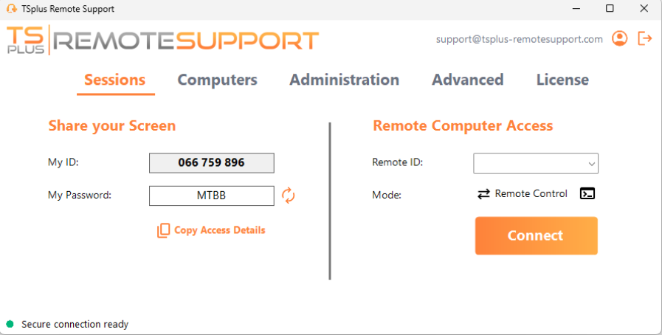

# Pre-Requisites:

* 1. Hardware
     + TSplus Remote Support runs on both 32 and 64-bit

editions of Windows computers

* + - TSplus Remote Support runs also on Mac OS and Android

# User Experience

* Lite connection client: Simplified end-user interface.
* Known Computers list: Each new connection is automatically added to a list of known PCs. Computers information can be edited at any time.
* Advanced Settings: Useful management tools. Users can enable unattended access to their device, and agents can generate clients, customize the required client’s information, and access helpful connection reporting.
* Direct Connection: automatic LAN connection between the agent and the end-user sharing its session, bypassing relay servers and therefore providing enhanced experience.
* Windows, Mac OS and Android compatibility

# Customization

The Administrator console offers customization options to keep control of the support environment.

* Use your Domain: Host your connection client

download using your branded domain.

* White Label: Add your branding to the Remote Support connection client.
* Adapt video quality: Scales display quality to accommodate bandwidth limitations. This keeps the connection working smoothly and quickly. Image scaling, screen resolution options.

# Manage Agent Accounts

Registering enables agents to retrieve their configuration from different computers. Agents can create a personal login with a password to easily access their records of user information and client IDs, including the list of unattended computers, from wherever they are regardless of the device they use to run Remote Support.

# Two access modes are available:

* "Remote Control" enables control of the remote session using your mouse and keyboard, while displaying the screen of the distant session.
* "Command Line" enables sending shell commands in the context of the remote session.

1. Operating system

https://tsplus.net/remote-support

TSplus Remote Support is compatible with the following operating systems:

* + - Windows 8/8.1
    - Windows 10 Home & Pro
    - Windows 11 Home & Pro
    - Windows Server 2008 R2 SP1
    - Windows Server 2012 or 2012 R2
    - Windows Server 2016
    - Windows Server 2019
    - Windows Server 2022
    - Mac OS Monterey 12.3 or later
    - Android **Marshmallow 6.0 (2015) or higher**

For Smartphone, Tablet, Android TV

*Windows PCs must have .NET v4.5.2 or higher installed.

There is no need for complicated installation or configuration. TSplus Remote Support only requires an Internet connection. Depending on the location of the agent and remote computers, and to ensure the best performance, multiple relay servers may be contacted by the Remote Support program. For networks with restrictive network policies, please allow outgoing connections to domain name *.tsplus- remotesupport.com from the agent and the remote computer.

For remote control functionality on Android, no specific permissions are required. However, to use the **sharing feature**, the following permissions need to be enabled:

* Capture Service: Enables sharing of your screen.
* Accessibility Service: Grants control over your device.

The trial version of Remote Support is the fully- featured edition, valid for 15 days, 5 concurrent connections.



**Contact** **us**

Name:

Address:

Tel:

Email: